Workdocument Project “Theodor”



Starting Date: 12-november-2016

Made by Ian Munster
Index
Introduction 2
Integrated Development Enviroment. 3
One Page Design 4
Flow Chart 5
Class Diagram 6
Scrum Method 7

Introduction

This is an ambitious game project started by me, Ian Munster Currently studying Game-Programming in the Netherlands (Media College, Amsterdam Sloterdijk)

The idea is to create a RolePlayingGame (RPG) that has the crusial Roleplaying aspects. like having multiple outcomes of the same problem based on the players decisions.

Integrated Development Enviroment.

Trello: https://trello.com/b/JymEGSe6/project-theodor

Github: https://github.com/IanMunster/ProjectTheodor/

Drive: https://drive.google.com/drive/folders/0B1Cqaz-_lCUxaEc3UXlOUHE3dUU

Unity 3D

Paint.net

One Page Design

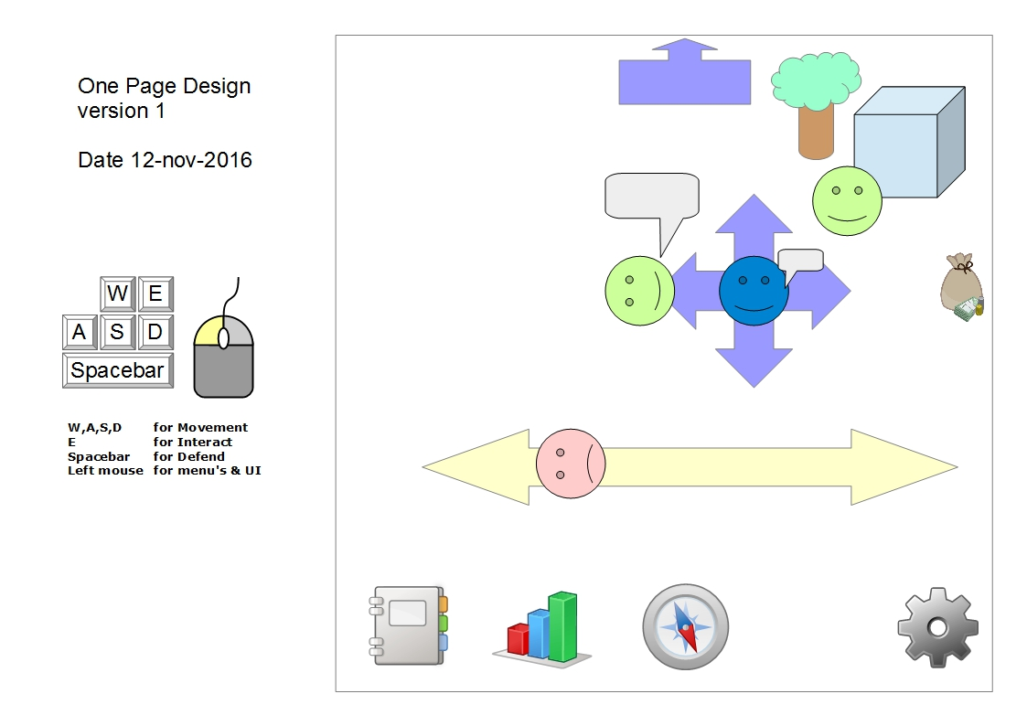

Flow Chart

Class Diagram

Scrum Method

